COS 214 – TEAM OBSIDIAN

Team Mates:
- Ngeletshedzo Mutwanamba (Team Leader) – u25039769
- Amira Ajanaku – u25111699
- Nare Maela - u24607917
- Nontokozo Madela - u25677404
- Manqoba Mashego – u24589137
- Giselle Mpye - u25622103
- Shepherd Nzimande - u25066120

Github Repo:
https://github.com/u25622103-droid/COS214-PROJ

Task 1: Research Findings on Workflow Management Systems
What is a workflow? A workflow is basically a business process that has been automated, where documents, information or tasks get passed between people following a set of rules. A workflow management system (WfMS) is the software that sets these workflows up and runs them, and the workflow engine is the part that does the actual running. Business process management (BPM) is the bigger picture, because it also covers analysing processes and how work is organised, not just automating it (Workflow Management Coalition, 1994).
Definition vs instance. The definition is the blueprint: the steps in a process and the rules for moving between them. An instance is one running copy of that blueprint. Lots of instances can run at the same time from one model, and each one deals with its own case, so each needs its own state and data (Workflow Management Coalition, 1994) (van der Aalst, 2013).
Activities and sub-processes. An activity is one step in the process, and when a person must do it, a work item shows up on their worklist. BPMN 2.0 splits tasks into user tasks (a human does it) and service tasks (a system does it). It also has sub-processes, which are activities with their own flow inside, and call activities, which reuse a process that is defined somewhere else (Object Management Group, 2011).
Routing. The workflow patterns research lists the basic ways to route work: sequence, parallel split (AND), synchronisation, exclusive choice (XOR), simple merge, multi-choice and loops. Different products support different ones, so it makes sense to keep routing flexible and not hard-code it (van der Aalst, et al., 2003).
Participants and assigning work. Engines look after worklists and who is signed in. The BPM survey describes people using roles and organisational units, including rules like the four-eyes principle, so the same person cannot do two dependent tasks. Work can reach people in two ways: the system pushes it to a worker, or the worker pulls it from the system (Workflow Management Coalition, 1994; van der Aalst, 2013; Russell et al., 2005) (Russell, et al., 2005).
Events, failures and external systems. In BPMN, boundary events sit on the edge of an activity and react while it is running. There are timer, message, error and escalation events. Compensation can undo activities that already finished if something goes wrong. The WfMC model also has separate interfaces for calling outside applications and talking to other workflow systems (Object Management Group, 2011).
History and changing definitions. Everything that happens gets saved in event logs, where each event points to an activity and a case, and process mining uses these logs to find out how processes really run. The WfMC treats audit as part of monitoring. To see how a real product deals with a definition changing while work is still running, we looked at the documentation of Camunda, a company that makes a workflow engine. In Camunda, a changed definition is saved as a new version. Running instances stay on the old version, new ones use the latest, and teams can choose to move running instances over without losing their history (van der Aalst, 2013) (Workflow Management Coalition, 1994) (Camunda, n.d).
What this means for TIVIDY. Our takeaway is that the engine should only know generic things like activities, instances, states, participants and events. Anything that changes between processes (the structure and versions, how work is grouped, routing, assignment and approval rules, events and integrations, and reports and rollback) should be able to change without touching the rest.

Task 2: Defining the scenario and system

In a meal plan order-to-delivery shopping system that offers custom meal packages for customers; Breakfast, Lunch and Diner. It manages customer orders from payment and coupon discounts, through kitchen cooking and packaging and finally courier handoff and delivery. The goal is to deliver the meal package to the customer successfully while keeping an accurate record of every step.

Workflow Definition (The Blueprint): A master checklist that says what steps must happen in what order and under what rules. When setting up a new meal plan, TIVIDY constructs the master template step by step. For example: It puts together the recipe: First validate coupon -> then prepare meals -> then package food -> then send via regional courier. (Builder)
Workflow instance (The active order): This is one order running through the system for a specific customer. TIVIDY creates brand new instances for a customer, and creates the exact task objects she needs (e.g. Breakfast or Lunch). A customer's order moves through cooking, packaging, and delivery independently. If the customer changes their address or cancels their order, it only affects their instance. Other customers' orders keep running smoothly without any bugs or interruptions. (Factory Method)

People and the Roles involved:
- Customers: choose meal package and place order, then applies discount coupons if any.
- Order engine(TIVIDY): Manages the process steps to complete order.
- Kitchen staff: Cooks food and packages meals
- 3 Delivery Services: Three different third-party courier companies that handle final delivery in different regions. TIVIDY connects their different systems using special bridges (Adapter).
- Branch Manager: A manager who resolves issues if food items run out or delivery fails (Chain of Responsibility).

Main Work Items and Packages
- Meal Packages: Orders can be single meals (Breakfast, Lunch, Dinner) or a full day bundle that groups them together (Composite).
- Discounts: Dynamic coupon rules wrap around the base order cost to apply savings based on the price of the order (Decorator).
- Packaging: Kitchen workers pack the meals once preparation is complete.

Decisions, Rules and Steps
- Status Updates: An order moves through clear statuses (Created -> Preparing -> Packaging -> In transit -> Delivered), and only allows valid actions each step (State).
- Dependencies: Packing can only start after all selected meals in a bundle are cooked and ready.
- Delivery Routing: TIVIDY automatically picks 1 of the 3 delivery companies based on the customer’s
delivery area (Strategy).
- Live Alerts: When kitchen staff finishes packaging, the order alerts the customer support and sends an SMS to the user automatically (Observer).

Fixing Problems and Undo Feature
- Out of stock issues: If ingredients run out, the issue gets passed up the chain from Kitchen staff to Supervisor to Manager until its solved (Chain of Responsibility).
- Cancelling or RollBack: If a user cancels an order or changes a coupon, TIVIDY takes a quick snapshot of the previous state to roll back cleanly without ruining history records (Memento).

Task 3: UML Activity Diagrams
1.

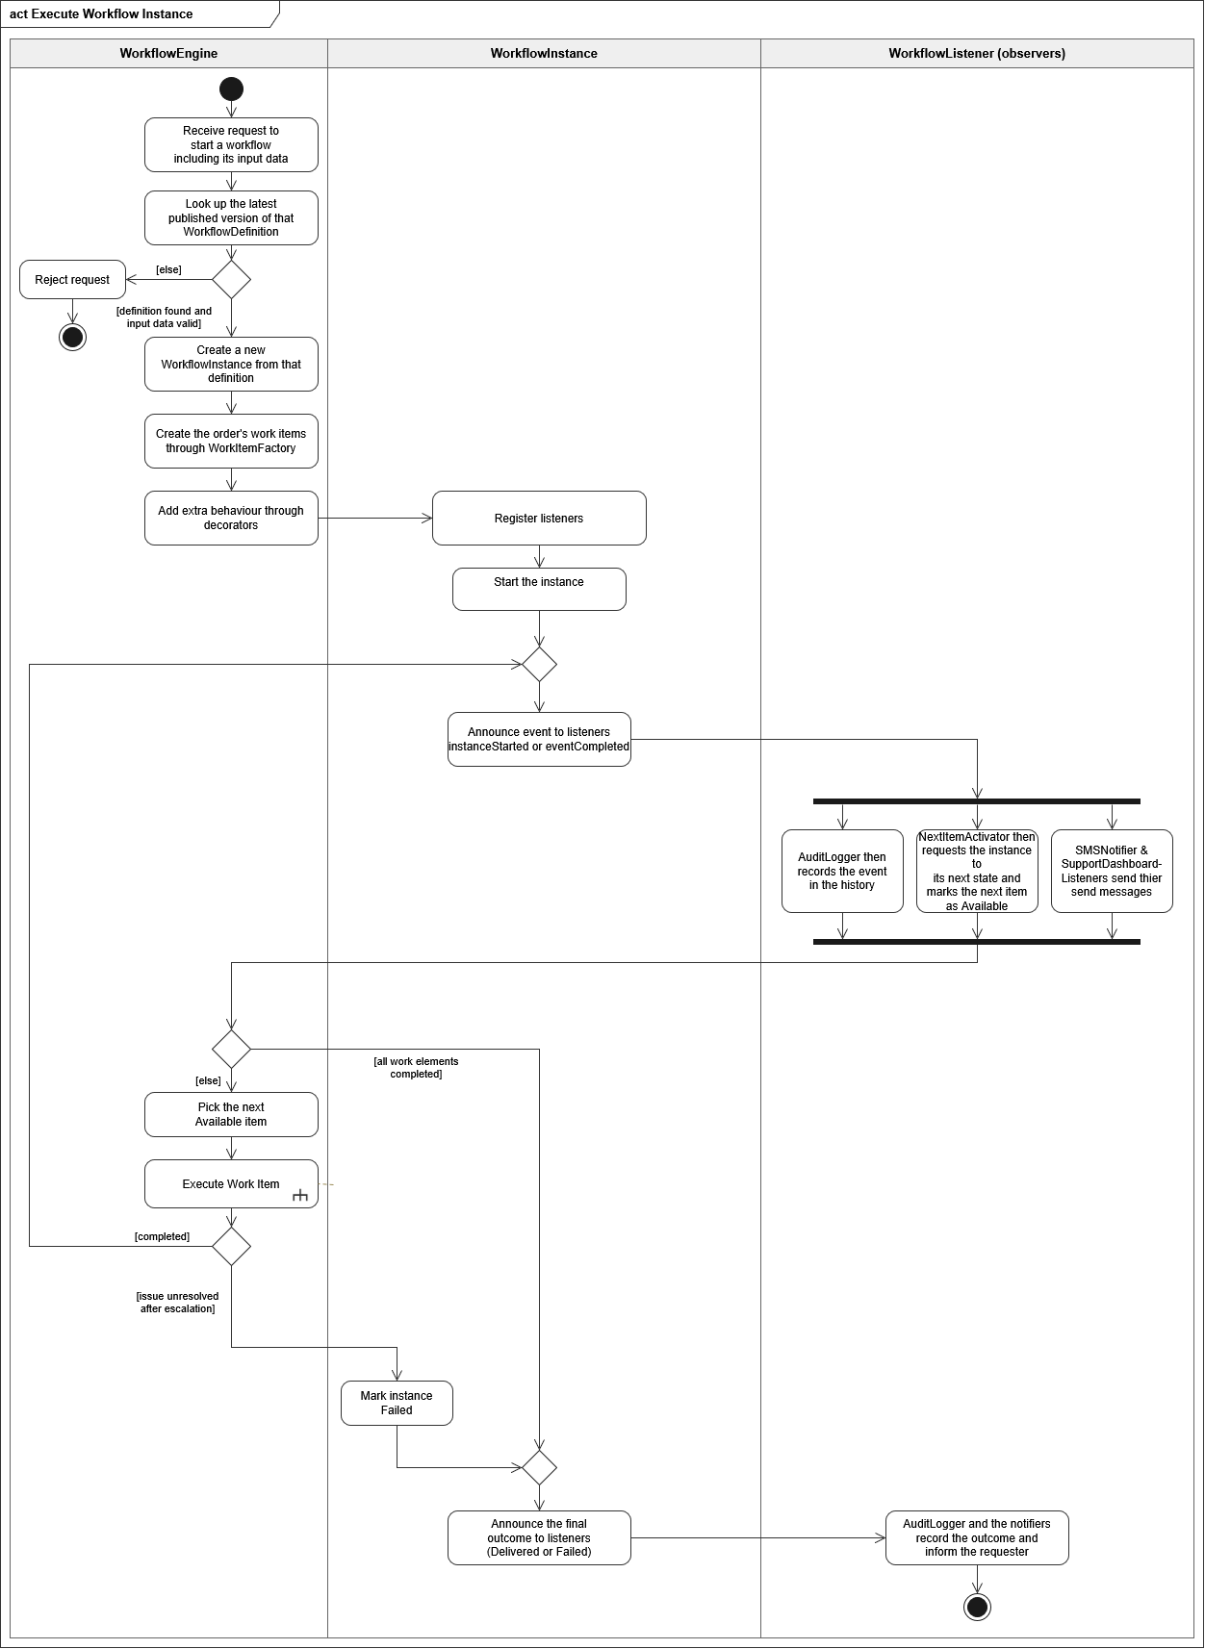

2.
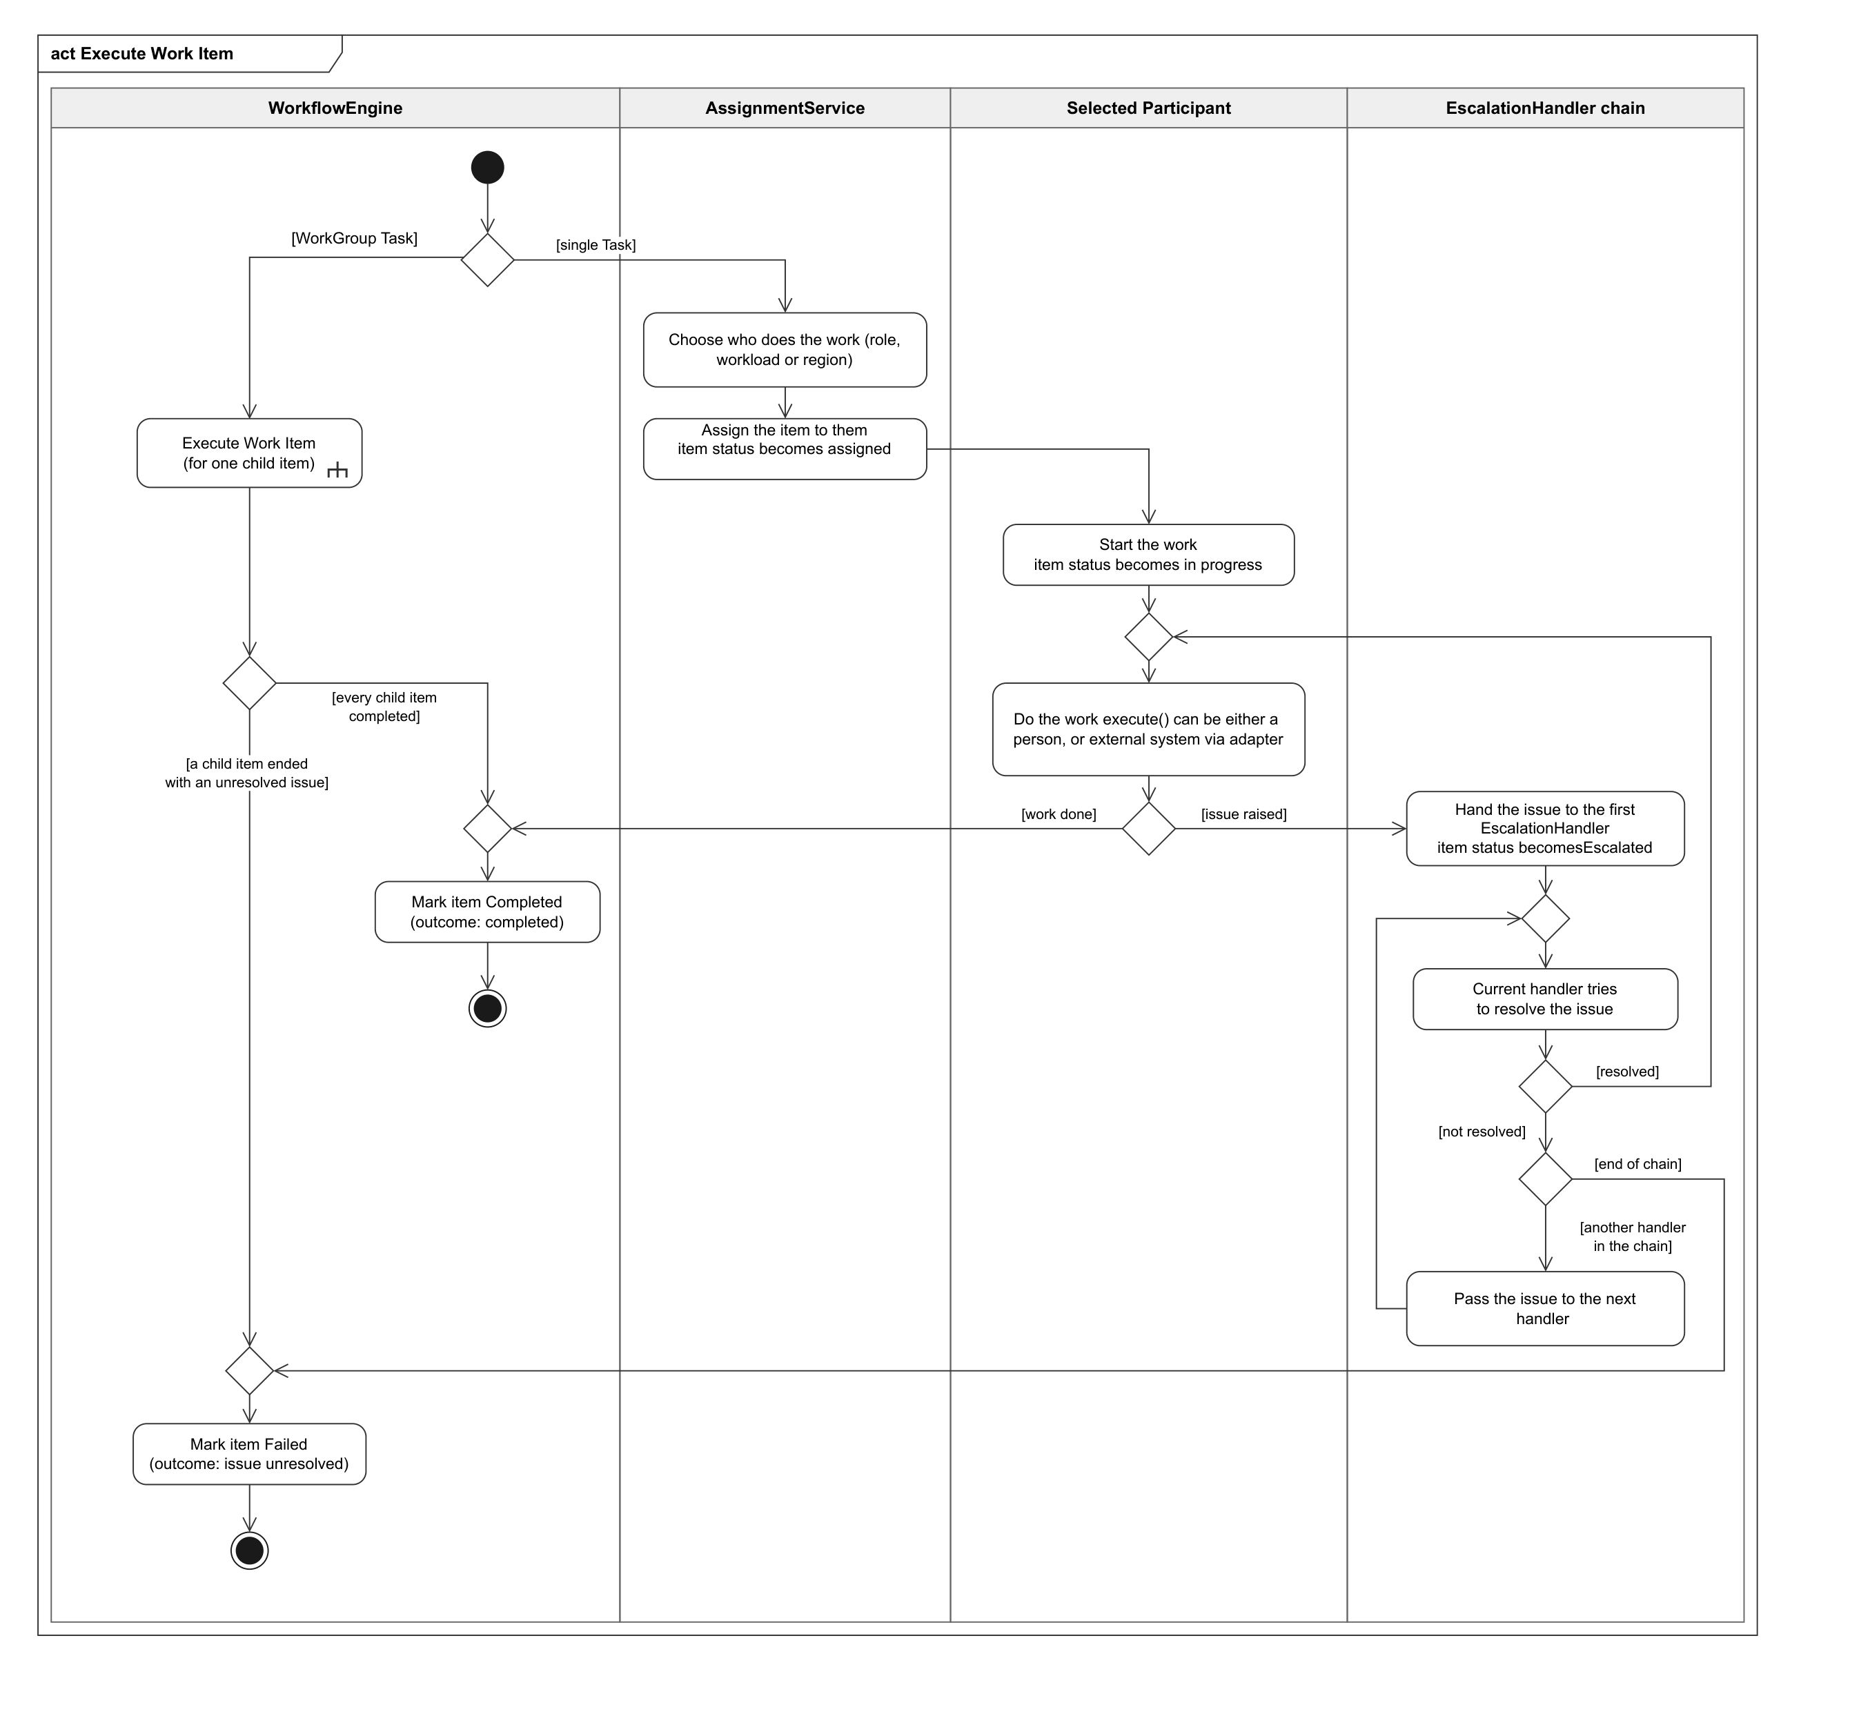

3.

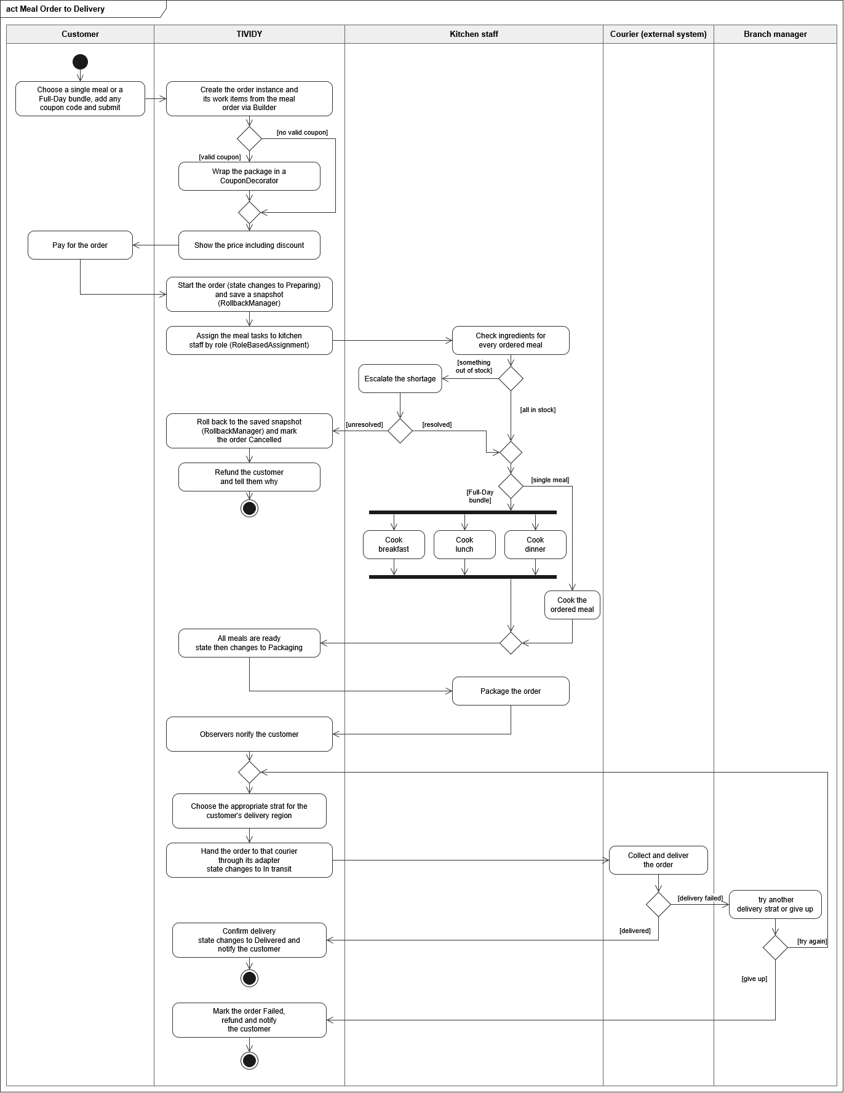

Task 4: Design Patterns
Each pattern’s problem is described using our meal-plan scenario as the worked example. All participating classes are generic workflow classes, and the scenario is applied to them through the workflow definition’s configuration.

Builder
Problem: A meal-plan definition is assembled in several steps (validate coupon → prepare meals →
package → courier delivery), with routing rules and an escalation chain attached. It must be complete and
validated before any customer order runs from it, and it must not change under running orders.

Participants:
GoF Participants | Class Names
Builder | WorkflowDefinitionBuilder
ConcreteBuilder | StandardDefinitionBuilder
Director | WorkflowDesigner
Product | WorkflowDefinition

Collaboration: The WorkflowDesigner directs the WorkflowDefinitionBuilder step by step, telling it which stages, work items, assignment rules and escalation chain to include. StandardDefinitionBuilder records each step into the definition under construction. Once the designer finishes, the builder checks that the definition is complete and hands back a versioned WorkflowDefinition.

Variation: The steps, their order and the rules attached to them (assignment strategy, escalation chain) differ for every kind of process. A new version of the definition is produced whenever any of them changes.
Why is it appropriate: The Builder is the construction side of the definition/instance split and the only place where a definition is created. By the time a WorkflowDefinition reaches the engine it is complete, validated and read-only, so later edits cannot disturb orders already running.

Factory Method
Problem: Every customer order is its own workflow instance and needs fresh task objects (these are the meal tasks and packaging for each customers order in our scenario) created from the shared definition. A change to one instance must never affect the other.

Participants:
GoF Participants | Class Names
Creator | WorkItemFactory
ConcreteCreator | UserTaskFactory, ServiceTaskFactory, ApprovalTaskFactory, ScriptTaskFactory, ParallelGroupFactory
Product | WorkElement
ConcreteProduct | UserTask, ServiceTask, ApprovalTask, ScriptTask, ParallelGroup

Collaboration: When an instance starts, the WorkflowEngine goes through each work-item spec in the WorkflowDefinition and hands it to the matching WorkItemFactory. The factory does the shared setup, such as linking the new element to the instance, while its concrete subclass decides which element to create, for example a UserTask or a ParallelGroup. The engine only receives a WorkElement back and never names a concrete class.
Variation: The kinds of work an instance contains differ between processes (meal tasks here, laboratory tests or approvals elsewhere), and new kinds appear over time. Only the creator hierarchy has to grow when this happens.

Why is it appropriate: The factory is the instance-creation side of the definition/instance split. It gives every instance its own freshly built objects from the shared definition, so changing one customer's address or cancelling their order cannot affect another order.

Composite
Problem: Work is nested: an instance may contain a single item or a group of items (in our scenario, a single meal or a full-day bundle), and a later item may start only when every item in the group before it is complete. The engine should treat an item and a group uniformly without type checks

Participants:
GoF Participants | Class Names
Component | WorkElement
Leaf | Task (UserTask, ServiceTask, ApprovalTask,ScriptTask)
Composite | WorkGroup (ParallelGroup)
Client | WorkflowEngine

Collaboration: The WorkflowEngine treats every WorkElement the same way and does not know whether it is a single Task or a WorkGroup. A ParallelGroup passes the engine's request on to its children, and it counts as complete only when all of them are complete.

Variation: The shape of an instance varies from a single task to a bundle of up to 4 tasks. In other workflows, work can nest more deeply as stages and sub-processes with parallel children.
Why is it appropriate: The Composite represents the nested work structure of a workflow. It lets the engine start, track and complete one meal or a whole bundle through one interface, so the packaging dependency does not need type checks or if/else chains.

State
Problem: A workflow instance’s valid actions depend on where it is in its lifecycle. Without a controlled lifecycle, every operation would have to check the status itself.

Participants:
GoF Participants | Class Names
State | InstanceState
ConcreteState | CreatedState, RunningState, SuspendedState, CompletedState, CancelledState,  FailedState
Context | WorkflowInstance

Collaboration: The WorkflowInstance hands every request it receives to its current InstanceState and does not decide anything itself. Each ConcreteState either carries out the request and switches the instance to the next state. CreatedState moves the instance to RunningState when it is started. RunningState moves it on to CompletedState when all work is done, to FailedState when an issue stays unresolved, to SuspendedState when it is paused, or to CancelledState when cancelling is allowed.

Variation: The statuses an order passes through, and the actions each one permits, differ between processes. A workflow with an approval stage, for instance, would add states and change which transitions are valid.

Why is it appropriate: The State pattern gives the running instance a controlled lifecycle. Every operation is checked by the current state, so invalid actions such as cancelling an order in transit are rejected in one place instead of through status flags and switch statements.

Strategy
Problem: The delivery step must choose one of three couriers based on the customer's area, and other organisations would assign work by role or workload instead.

Participants:
GoF Participants | Class Names
Strategy | AssignmentStrategy
ConcreteStrategy | RoleMatchStrategy, LeastLoadedStrategy, AttributeMatchStrategy
Context | AssignmentService

Collaboration: When a work item becomes available, the AssignmentService asks the AssignmentStrategy named in the definition to choose a participant from the candidates. AttributeMatchStrategy compares a field in the workflow data, such as an area, with the attributes of each candidate and picks the one that matches, and the AssignmentService then gives the item to that courier. Another workflow could name a different strategy without the AssignmentService changing.

Variation: How work is assigned differs between organisations and even between work items, whether by role, by workload or by a rule on workflow data such as delivery area. Each of these rules is a separate algorithm that can be swapped without touching the tasks.
Why is it appropriate: The Strategy is the routing and assignment decision point of the system. It keeps the question "who does this work" out of the task classes, so changing the rule, or choosing a different courier-selection approach, does not require rewriting any work item.

Chain of Responsibility
Problem: When ingredients run out or a delivery fails, the issue must climb from kitchen staff to supervisor to branch manager until someone resolves it, and nobody should need to know who handles what.

Participants:
GoF Participants | Class Names
Handler | EscalationHandler
ConcreteHandler | FrontlineHandler, SupervisorHandler, ManagerHandler
Client | WorkflowEngine

Collaboration: When a task reports an Issue, the WorkflowEngine passes it to the first FrontlineHandler, the lowest level in the chain. Each handler either resolves the issue that is within its authority or passes it to the next one (SupervisorHandler, then ManagerHandler). If the ManagerHandler cannot resolve it, the engine marks the instance as failed.

Variation: The number of escalation levels, their order, and which kinds of issue each level can resolve differ between organisations and between types of problem.

Why is it appropriate: This pattern is the exception-handling side of the system. The code that raises an issue does not need to know who resolves it. The engine only needs to know the first handler in the chain.

Observer
Problem: When packaging finishes, several unrelated things must happen: customer support is alerted, an SMS goes out, the audit log is written, and the next step is made available. The core model shouldn't know about any of them.

Participants:

GoF Participants | Class Names
Subject | WorkflowEventPublisher
ConcreteSubject | WorkflowInstance
Observer | WorkflowListener
ConcreteObserver | AuditLogger, NextItemActivator, NotificationListener,  DashboardListener

Collaboration: The listeners register with the WorkflowInstance when it is created. When a task finishes, the instance publishes an event to all of them without knowing what they do. NotificationListener messages the concerned people, DashboardListener updates a live view of a workflow status, AuditLogger adds the event to the history, and NextItemActivator makes the next work item available, which can also move the instance on to its next state. The listeners work independently and do not know about each other.

Variation: Which parts of the system care about a given event, and what they do in response, differ between workflows and organisations. The same event might trigger an SMS today and an email or a warehouse update tomorrow.

Why is it appropriate: The Observer decouples the core model from everything that reacts to it. The model publishes events without knowing who receives them, so a new notification or integration only needs a new listener to be attached.

Adapter
Problem: TIVIDY must call external systems whose interfaces it did not design (in our scenario, the three couriers expose a web API, a legacy interface and a message queue), but a service task must work with any of them.

Participants:
GoF Participants | Class Names
Adaptee | RestApiClient, LegacySystemApi, MessageQueueClient
Target | ExternalServiceConnector
Adapter | RestApiAdapter, LegacySystemAdapter, MessagingAdapter
Client | ServiceTask

Collaboration: The ServiceTask works only with the ExternalServiceConnector interface, using the service chosen by the Strategy. The matching adapter holds that system’s client, translates TIVIDY’s request into its own format, and converts the response back into something TIVIDY understands.

Variation: Each courier exposes a different interface, data format and status vocabulary, and the set of external systems can grow or change over time.
Why is it appropriate: The Adapter is the integration boundary of the system. The engine and ServiceTask depend only on ExternalServiceConnector, so foreign systems stay outside the core and adding a fourth courier means writing one new adapter.

Decorator
Problem: A work element sometimes needs extra behaviour wrapped around it, such as applying a discount coupon to the order cost, writing audit entries or raising its priority. These extras must be combinable in any order without a separate subclass for every combination, and without making the task a different kind of task.

Participants:
GoF Participants | Class Names

Component | WorkElement
ConcreteComponent | Task (UserTask, ServiceTask, ApprovalTask, ScriptTask), ParallelGroup
Decorator | WorkElementDecorator
ConcreteDecorator | PayloadDecorator, AuditedDecorator,  PriorityDecorator

Collaboration: Each decorator shares the WorkElement interface and wraps another WorkElement. For example, PayloadDecorator wraps a ParallelGroup and applies its configured rule to the group’s data before the value reaches the engine. Decorators can be wrapped around each other, such as AuditedDecorator around PayloadDecorator around the group, and each passes everything else straight through to the element inside it.

Variation: Which extras apply to an item (one or several data rules, auditing, priority) differs per order and per workflow.
Why is it appropriate: The Decorator lets cross-cutting behaviour be attached to tasks and bundles without modifying them or creating a subclass per combination.

Memento
Problem: If the customer cancels or changes a coupon or address, the order must return to its previous state cleanly, and the history of what happened must not be erased.

Participants:
GoF Participants | Class Names
Originator | WorkflowInstance
Memento | InstanceSnapshot
Caretaker | RollbackManager

Collaboration: Before a risky change, the RollbackManager asks the WorkflowInstance to save a copy of its current state, and it stores the resulting InstanceSnapshot without reading it. On rollback, the manager gives the latest snapshot back to the instance, which restores itself from it. The AuditLogger then records the rollback, so the history only grows.

Variation: What needs to be captured (payload, states, assignments) and how many levels of undo are kept can differ between workflows.

Why is it appropriate: The Memento is the undo and rollback side of the system. Restoring from a snapshot returns the order to a known-good point while the history only grows, so the record stays accurate.

Template Method
Problem: Every work item follows the same lifecycle when it runs: check that it is ready, do the work, record the outcome, and notify the interested listeners. The “do the work” step is completely different for each kind of task and without a shared skeleton, each task kind would repeat the same steps.

Participants:
GoF Participants | Class Names
AbstractClass | Task
ConcreteClass | UserTask, ServiceTask, ApprovalTask, ScriptTask

Collaboration: The WorkflowEngine runs a Task without knowing which kind it is. The Task fixes the order of the steps: it first checks that it is ready, then carries out the work, then records the outcome and notifies the listeners. Only the work step is left to the subclass. A UserTask waits for its assigned participant to finish, a ServiceTask passes the work to an external service through its connector, an ApprovalTask waits for an approval decision, and a ScriptTask runs a configured rule inside TIVIDY.

Variation: How the work itself gets done differs between kinds of task, and new kinds (a timed task, a scripted task) can appear, while the order of the surrounding steps stays fixed.

Why is it appropriate: It guarantees that every task is checked, recorded in the audit history and announced in exactly the same way, and it means the engine never has to branch on the kind of task.

Command
Problem: Actions on a workflow, such as starting it, cancelling it, changing its data or reassigning an item, need to be queued, logged and sometimes undone. If these actions are just direct method calls, the history can only show that something changed and they cannot be queued.

Participants:
GoF Participants | Class Names
Command | WorkflowCommand
ConcreteCommand | StartInstanceCommand, CancelInstanceCommand, ChangeDataCommand, ReassignItemCommand
Invoker | CommandInvoker
Receiver | WorkflowInstance
Client | TividyFacade

Collaboration: The TividyFacade receives a client’s request and wraps it in a command object that carries everything needed to carry it out, including the WorkflowInstance it applies to. The facade passes the command to the CommandInvoker, which holds it until its turn and then runs it. For commands that change an instance, the invoker first has the RollbackManager save a restore point, so the command and its restore point are kept together.

Variation: The kinds of request that clients and operators can make differ between processes and keep growing, for example rescheduling or adding data. Each new request is a new command, and the invoker and the instance do not change.

Why is it appropriate: The Command is the part of the system that treats a request as something that can be kept, scheduled and reviewed, and not as a call that is made and forgotten. It sits between the entry point and the instance, so every change to a running workflow passes through one place where it can be queued, recorded and, where it makes sense, reversed.

Iterator
Problem: The engine needs to step through a group’s work items one at a time, for example to find the next available item, and the audit history needs to be read entry by entry for reports.

Participants:
GoF Participants | Class Names
Iterator | WorkIterator
ConcreteIterator | DepthFirstIterator, AvailableItemIterator, AuditEntryIterator
Aggregate | WorkIterable
ConcreteAggregate | ParallelGroup, AuditHistory

Collaboration: When the engine needs the work items of a group, it asks the group for an iterator and then moves through the items one by one, without seeing how the group stores them. The AvailableItemIterator skips items that are already complete or not yet available. The DepthFirstIterator goes into nested groups so that every task is reached. The AuditHistory hands out an AuditEntryIterator so that reports can read the log in order without seeing its storage.

Variation: The order in which work is visited, and which items are of interest, depend on the question being asked and on how deeply a process nests. A new traversal is a new iterator, and the groups and the log stay as they are.

Why is it appropriate: The Iterator is how the rest of the system walks through the pieces of work in the Composite and through the audit history, without depending on how either is stored.

Facade
Problem: To start a workflow, the outside world would otherwise have to deal with the designer and builder, the engine, the rollback and command history, the assignment service and the audit log. This leaks the system’s structure to every user of TIVIDY and makes it easy to call things in the wrong order.

Participants:
GoF Participants | Class Names
Facade | TividyFacade
Subsystem classes | WorkflowDesigner, WorkflowEngine, CommandInvoker, RollbackManager, AuditLogger, AssignmentService

Collaboration: The client talks only to the TividyFacade. When it wants a new workflow, the facade gets a definition from the designer, has the engine start an instance from it, and sets up the listeners. When the client asks to cancel or change workflow, the facade passes the request to the command invoker. The subsystem classes do the work and do not know the facade exists.

Variation: The set of simple operations that clients need (start, cancel, track, report) can change and grow without changing the subsystem classes behind them.

Why is it appropriate: Facade is the entry point of the system. It hides the many cooperating subsystems behind a few operations, so the rest of the application can use TIVIDY without knowing its structure, and the subsystems can be reorganised without affecting users.

Task 5: UML ClassDiagram

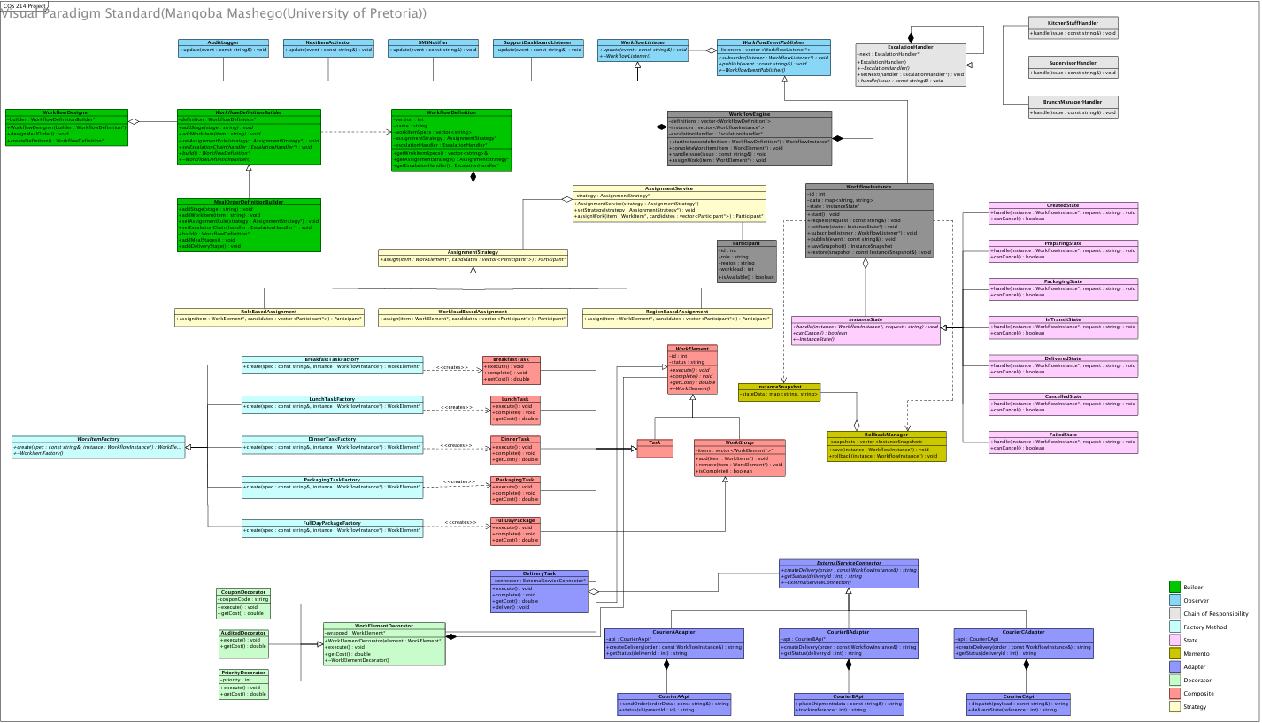

Task 6: Runtime Behaviour Diagrams
UML Sequence Diagram: Creating and starting a workflow instance
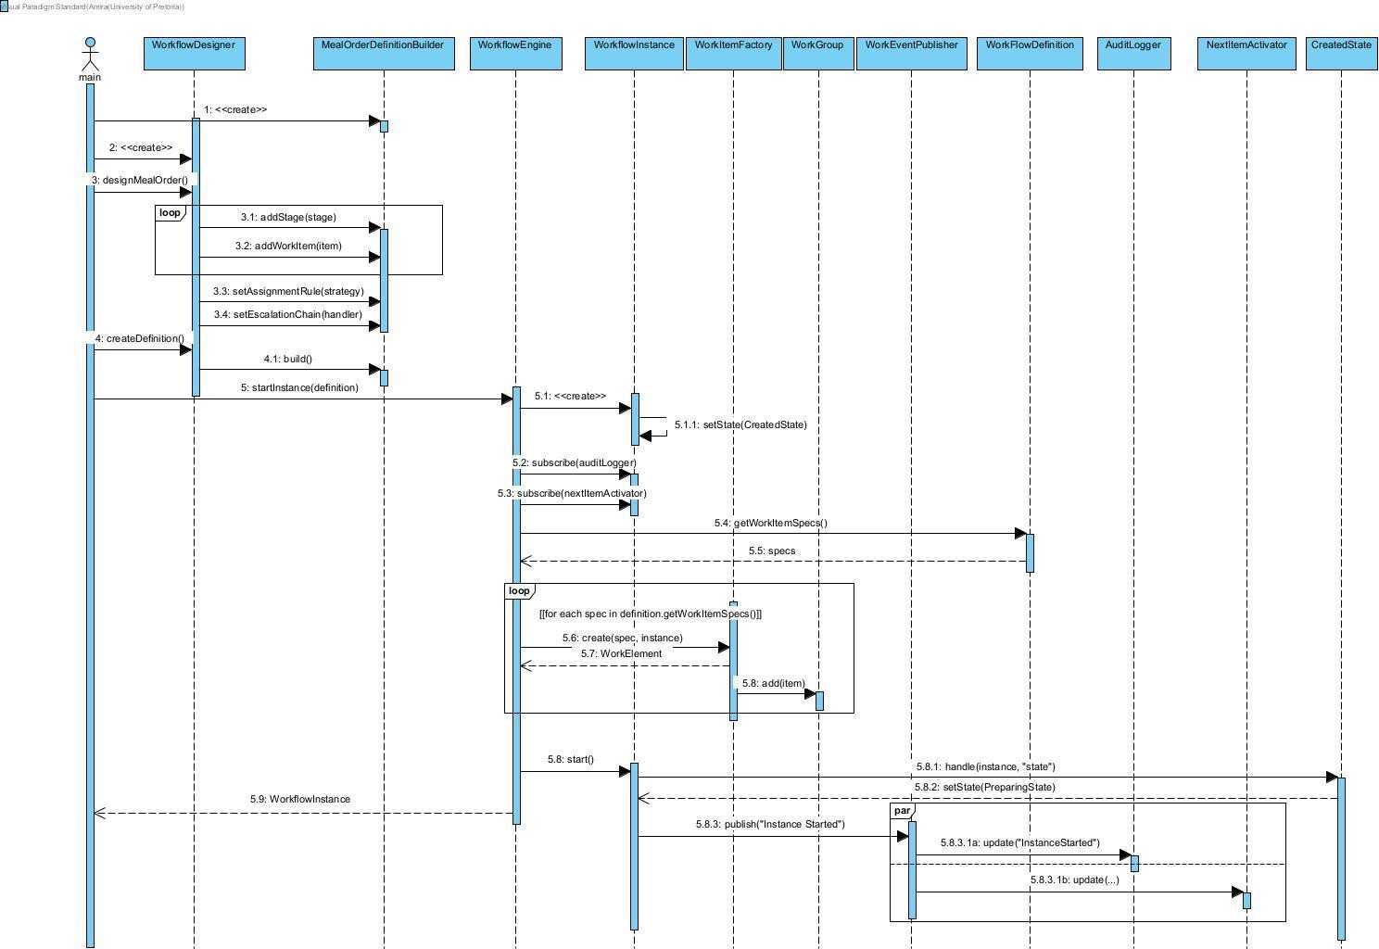
UML Sequence Diagram: Completing a work item, assigning the next one, and handling a courier failure

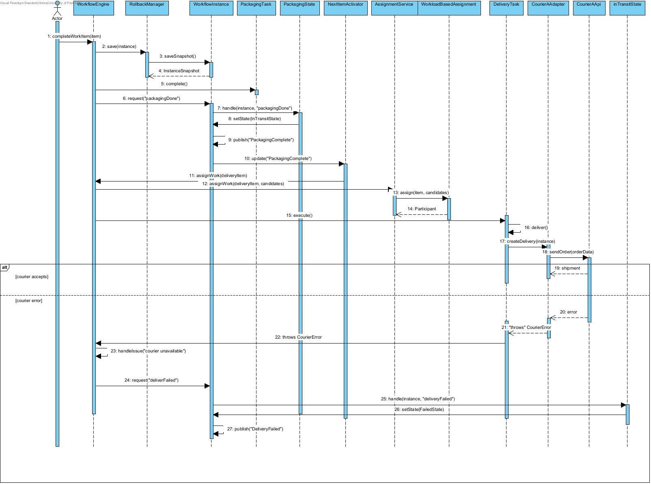
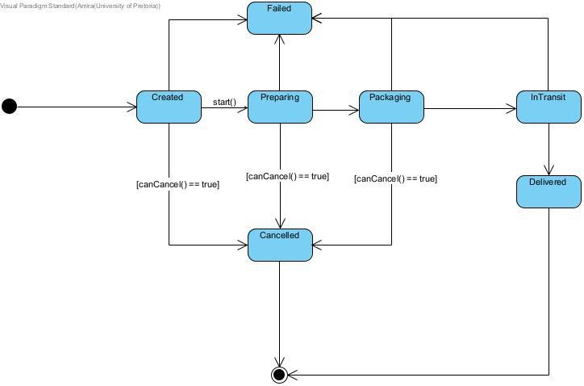
UML State Diagram: Workflow instance lifecycle

Task 7

The problem or question being considered:
  - Whether the name that we have given to our uml class diagram is too specific to the scenario rather than that of a general workflow system that should be able to work for multiple systems.

the original design or assumption:
  - A few of our initial class names used vocabulary closely linked to our chosen scenario that will be used to test our workflow. Such as kitchenstaff manager, branch manager and other similar role specified classes.

the change that was made:
  - Changes have not been made yet as it is something we will discuss with our tutor during consultation. Once it has been discussed and we have decided as a group we will then make the relevant updates to the required diagrams/sections.

why the change is likely to be made:
  - To make our workflow system fit a more general sense so that it can be reused for multiple different purposes. This also helps to improve our level of abstraction.
- updates to the relevant diagrams:
  - None at this current moment

Contribution Statement

For this deliverable, tasks were allocated based on what each member felt was their strength and/or interest. The work was mostly divided by tasks with members then pushing the work from their branches to the main as each task finished allowing us to work in parallel. Once a member finished a section of the specification, they would notify the rest of us as teammates to verify what had been submitted and allow each other the opportunity to offer our opinions on anything that we felt needed to change. All members reviewed the integrated design to ensure the diagrams and documentation told a coherent story. The task allocation was as follows:
- Task 1 : Giselle
- Task 2: Nontokozo
- Task 3: Shepherd
- Task 4: Ngeletshedzo
- Task 5: Manqoba
- Task 6: Amira
- Task 7/ Pdf: Nare

References
Camunda, n.d. Versioning process definitions. [Online]
Available at: https://docs.camunda.io/docs/components/best-practices/operations/versioning-process-definitions/
[Accessed 04 10 2026].
Object Management Group, 2011. Business Process Model and Notation (BPMN). [Online]
Available at: https://www.omg.org/spec/BPMN/2.0/PDF [Accessed 04 10 2026].
Russell, N., van der Aalst, W., ter Hofstede, A. & Edmond, D., 2005. Workflow resource patterns: identification, representation and tool support. Berlin, Springer.
van der Aalst, W., 2013. Business process management: a comprehensive survey. ISRN Software Engineering, pp. 1-37.
van der Aalst, W., ter Hofstede, A., Kiepuszewski, B. & Barros, A., 2003. Workflow patterns. Distributed and Parallel Databases, 14(1), pp. 5-51.
Workflow Management Coalition, 1994. The Workflow Reference Model. [Online]
Available at: https://www.aiai.ed.ac.uk/project/wfmc/ARCHIVE/DOCS/refmodel/rmv1-16.html [Accessed 04 10 2026].

